Manila Water CompanyCustomer NameDocument Title

FUNCTIONAL SPECIFICATION – ENHANCEMENT

DID_R2R_211 - Interest Rates Blotter
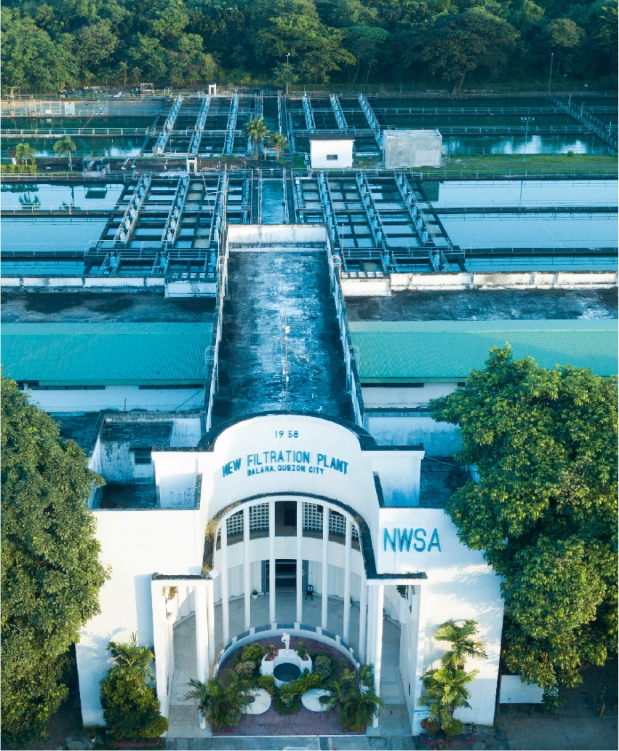





Contents
1 Document Organization 3
1.1 Document Log 3
1.2 Integration, Document Reference 3
2 Justification 4
3 Functional Description 4
4 Security / Authorization Requirements 9
4.1 Definition 9
4.2 Defined Fields 9
4.3 Procedure 10
5 Dependencies / Constraints 10
6 Assumptions 10
7 Security Requirements 10
8 Functional Requirement 10
8.1 Flow of Enhancement 10
8.2 Layout 11
9 Assumptions in Functional Design 11
10 Open Issues in Functional Design 11
11 Business Test Conditions 11
12 Related Documentation 11

Document Organization
This section provides details about this document, previous version(s) of this document and the document(s) referred.

Document Log
Following table mentions the version changes and the processer(s):
Version | Status | Date | Version Created by (Name/E-Mail/Company) | Role | Comments
0.1 | Draft | November 25, 2024 | Ravi Yadav  ravi.yadav@sap.com | Author | Initial draft
0.2 | Ready for Review | December 4, 2024 | Roopali Sharma  roopali.sharma02@sap.com  Mohanrangan  Mohanrangan.rangarajan@sap.com | Reviewer | Technical Review
0.3 | Reviewed with Comments | January 20, 2025 | MWC Product Owners  Value Delivery Leads | Reviewer | Business Review
1.0 | Final | January 22, 2025 | Ravi Yadav  ravi.yadav@sap.com | Author | Final Version

Integration, Document Reference
S. No. | Referred Document Name | Referred Document Version | Referred Document URL (Optional)
1 | MWC_SDD_TRM_03_Treasury and Risk Management | Final V2.0

The documents listed here are explicitly not part of this Functional Specification. They are not automatically accepted together with this Specification but may be subject to separate customer/SAP acceptance.

Justification
MWC obtains bids regarding contract rates from various financial institutions before entering into a financial contract(s) with one or more of them. MWC receives offers from banks for different product types such as placements, and spots.

These bids need to be captured in S/4 system for necessary review and decision making of business accountants before creating a TRM contract in the S/4 system. Moreover, these details of offers received is a vital input for daily business reports like Deal Slip - Placements and Deal Slip - Forex.

Unlike ECC, there is no standard functionality in S/4HANA to capture such offers, thus, an enhancement is required to develop such a process in S/4 system as per business requirements. This document captures the essential technical details like input screen, database table, and validations to capture the bids received from various banks.

Functional Description
To capture the bids, the following product types are applicable: -
S. No. | Product Type | Product Code | Product Description | Transaction Type
1 | Money Market | PN | Promissory Notes | 100 (Investment)
2 | Money Market | TD | Time Deposits | 100 (Investment)
3 | Money market | CS | Current Account / Savings Account Contracts | 100 (Investment)
4 | Foreign Exchange | 60A | Foreign Exchange | 101 (SPOT)

Following custom table ZTRM_INT_RATES_BLOTTER needs to be created in S/4: -
S. No. | Field Name | Type | Value
1 | Company Code | Alphanumeric (4) | F4 help (T001)  where country = ph  F4 Help (TRGC_TR_ACC_CODE)
2 | product type | Alphanumeric (3) | F4 Help (TZPA)  where product category = 550, 560 & 600
3 | Trasaction type | numeric (3) | f4 help (At10 – SFHAART & AT10-XTEXT) for the product type
4 | Term start | date
5 | term End  value date | date
6 | trans. amount | numeric
7 | Trans. currency | CHAR | F4 Help (tcurc)
8 | Interest Calculation method | char (01)
9 | frequency indicator | Numc (1)
10 | Calculation period | char (1)
11 | defined freq in days/months | numeric (3)
12 | buy amount | numeric
13 | buy currency | CHAR | F4 Help (tcurc)
14 | sales amount | numeric
15 | sales currency | CHAR | F4 Help (tcurc)
16 | partner | Alphanumeric (8) | F4 Help (BUT100)  where BP role = tr0151
17 | percent / rate | numeric (2)
18 | spot rate | numeric (2)
19 | swap rate | numeric (2)
20 | offer no | numeric (8) | Primary key
21 | transaction | numeric (8) | f4 help (VTBFHA)  display only
22 | remarks | char (100) | Text field

As per business feedback during TTT sessions, following is the table structure for Placement - Offers: -
ZDT_TRM_FD_HDR
S. No. | Field Name | Type | Value
1 | Company Code | Alphanumeric (4)  KEY field | F4 help (T001)  where country = ph  F4 Help (TRGC_TR_ACC_CODE)
2 | Fiscal Year | date  key field
3 | Offer no | numeric (8)  key field | Primary key
4 | product type | Alphanumeric (3) | F4 Help (TZPA)  where product category = 550, 560 & 600
5 | Trasaction type | numeric (3) | f4 help (At10 – SFHAART & AT10-XTEXT) for the product type
6 | portfolio | Alphanumeric (10)
7 | Term start | date
8 | term End | date
9 | trans. amount | numeric
10 | Trans. currency | CHAR | F4 Help (tcurc)
11 | Interest Calculation method | char (01)
12 | frequency indicator | Numc (1)
13 | Calculation period | char (1)
14 | defined freq in days/months | numeric (3)

ZDT_TRM_FD_TKTS
S. No. | Field Name | Type | Value
1 | Company Code | Alphanumeric (4)  KEY field | F4 help (T001)  where country = ph  F4 Help (TRGC_TR_ACC_CODE)
2 | Fiscal Year | date  key field
3 | Offer no | numeric (8)  key field | Primary key
4 | product type | Alphanumeric (3) | F4 Help (TZPA)  where product category = 550, 560 & 600
5 | Trasaction type | numeric (3) | f4 help (At10 – SFHAART & AT10-XTEXT) for the product type
6 | tickets | alphanumeric (25)

ZDT_TRM_FD_OFFERS
S. No. | Field Name | Type | Value
1 | Company Code | Alphanumeric (4)  KEY field | F4 help (T001)  where country = ph  F4 Help (TRGC_TR_ACC_CODE)
2 | Fiscal Year | date  key field
3 | Offer no | numeric (8)  key field | Primary key
4 | partner | Alphanumeric (8) | F4 Help (BUT100)  where BP role = tr0151
5 | PType | Alphanumeric (3) | F4 Help (TZPA)  where product category = 550, 560 & 600
6 | TType | numeric (3) | f4 help (At10 – SFHAART & AT10-XTEXT) for the product type
7 | contract rate | numeric (2)
8 | amount | numeric (23,2)
9 | original limit | numeric (23,2)
10 | available limit | numeric (23,2)
11 | concentration | numeric (2,2)
12 | start of term | date
13 | tenor | numeric (4)
14 | end of term | date
15 | interest | numeric (23,2)
16 | transaction | numeric (8) | f4 help (VTBFHA)  display only
17 | remarks | char (100)

As per business feedback during TTT sessions, following is the table structure for Forex - Offers: -
ZDT_TRM_FX_HDR
S. No. | Field Name | Type | Value
1 | Company Code | Alphanumeric (4)  KEY field | F4 help (T001)  where country = ph  F4 Help (TRGC_TR_ACC_CODE)
2 | Fiscal Year | date  key field
3 | Offer no | numeric (8)  key field | Primary key
4 | product type | Alphanumeric (3) | F4 Help (TZPA)  where product category = 550, 560 & 600
5 | Trasaction type | numeric (3) | f4 help (At10 – SFHAART & AT10-XTEXT) for the product type
6 | portfolio | Alphanumeric (10)
7 | Year | date
8 | buy amount | numeric
9 | buy currency | CHAR | F4 Help (tcurc)
10 | sell amount | numeric
11 | sell currency | CHAR | F4 Help (tcurc)
12 | total amount | numeric
13 | value date | date
14 | type | char (6)

ZDT_TRM_FX_TKTS
S. No. | Field Name | Type | Value
1 | Company Code | Alphanumeric (4)  KEY field | F4 help (T001)  where country = ph  F4 Help (TRGC_TR_ACC_CODE)
2 | Fiscal Year | date  key field
3 | Offer no | numeric (8)  key field | Primary key
4 | product type | Alphanumeric (3) | F4 Help (TZPA)  where product category = 550, 560 & 600
5 | Trasaction type | numeric (3) | f4 help (At10 – SFHAART & AT10-XTEXT) for the product type
6 | tickets | alphanumeric (25)

ZDT_TRM_FX_OFFERS
S. No. | Field Name | Type | Value
1 | Company Code | Alphanumeric (4)  KEY field | F4 help (T001)  where country = ph  F4 Help (TRGC_TR_ACC_CODE)
2 | Fiscal Year | date  key field
3 | Offer no | numeric (8)  key field | Primary key
4 | partner | Alphanumeric (8) | F4 Help (BUT100)  where BP role = tr0151
5 | PType | Alphanumeric (3) | F4 Help (TZPA)  where product category = 550, 560 & 600
6 | TType | numeric (3) | f4 help (At10 – SFHAART & AT10-XTEXT) for the product type
7 | spot rate | numeric (2)
8 | swap rate | numeric (23,2)
9 | original limit | numeric (23,2)
10 | available limit | numeric (23,2)

Primary Key (Key Fields): Company Code; Product Type; Transaction Type; Fiscal Year (based on System Date); Offer No.; and Partner; Term Start; End Term
During offers creations, fetch last offer no. from table at the level of Company Code, Product Type, Trans. Type, and Fiscal Year. In case of no rows fetched from custom table, start first Offer No. with 100001.

Selection Criteria
Initial input Screen (Screen 1): -
- Separate Fiori apps for the following processes: -
  - Create Offer – This will display the Screen 3.
  - Edit Offer – Upon selecting a specific offer on Screen 2, it will display the result on Screen 3.
  - Display Offers - Upon selecting a specific offer on Screen 2, it will display the result on Screen 3.

Input selection parameters: -
Table/  Structure Name | Field Name | Format | Default Value | Table Value/  Checkbox/  Radio Button/  Radio Button Group | Select Option or Parameter | Mandatory or Optional | Field Labels
T001  TRGC_TR_  ACC_CODE | Company Code | Alphanumeric | M001 | Table Value | Select Option | M (Single) | Company Code
TZPA | Product Type | Alphanumeric | TD | Table Value | Select Option | M | Product Type
At10 | Transaction Type | Numeric | 100 | Table Value | Select Option | O | Transaction Type
BUT100 | Partner | Alphanumeric | N/A | Table Value | Select Option | O | Partner
 | Start Date | Date | System Date |  | Select Option | O | Start Date
 | End Date | Date | System Date |  | Select Option | O | End Date
ZTRM_INT_  RATES_BLOTTER | Offer No | Numeric | USD | Table Value | Select Option | O | Offer No.
***Note: Start Date, End Date and Offer No are applicable only to Edit Offer / Display Offer.

Create Offer Number (Screen 3)
Following is the input screen for the offers related to placements: -
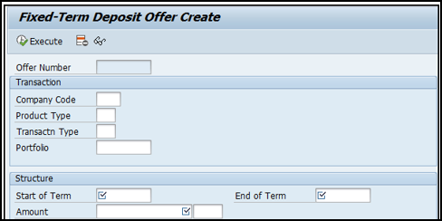
Tenor = End of Term – Start of Term (Display)
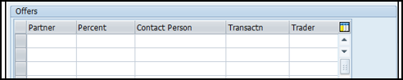

Following is the input screen for the offers related to Forex- Spot: -
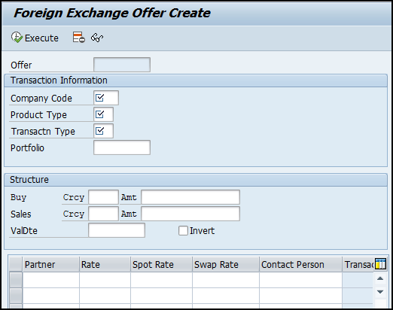

- Remarks column to be added. (Length 100) at the line-item level.
- Contact Person and Trader is not Required.
- If frequency = 0 (Manual Input) in FD contracts, then pass following fields in BAPI: -
  - Effective From Date
  - Due Date
  - Calculation Date
- For forex contracts, pass following fields in BAPI: -
  - Traded Currency
  - Lead Currency
  - Follow Currency
- For forex contracts, no input Amount required for Sales currency. This will be auto-calculated using Buy Amount and Rate.

Save the above entered data in the custom table ZTRM_INT_RATES_BLOTTER.
Offer Number is generated. This will be picked from number range table based on company code, product type and transaction type.

Once a trader selects an appropriate offer and clicks on Execute button, create a TRM contract using below BAPIs: -
- Fixed Deposits: BAPI_FTR_FXT_DEALCREATE
  - Structure: FIXEDTERMDEPOSIT & GENERALCONTRACTDATA (GVC)
- Forex: BAPI_FTR_FXT_DEALCREATE
  - Structure: FOREX & GENERALCONTRACTDATA (GVC)

‘Best Quote’ button (on Screen 3): When clicked, system to display a pop-up message citing best quote depending on the following criterion: -
- Interest Rate
- Credit Limit
  - For the company code and partner, read Limit Type and Limit Record from table VTBLS where Limit Type = 100
  - For the Limit Type and Limit Record, read Internal Limit and Credit Limit Utilization from table VTBLV where Valid To ≥ Current Date.
  - For the Limit Type and Limit Record, read Total Utilization Amount from table VTBLIS where Limit Utilization Base = 2 and max (Validity Date for Utilization) and latest Determination Date (DLI) and Valid To ≥ Current Date.
    - If no rows returned, the Total Utilization Amount = 0.
  - Condition: Internal Limit > Total Utilization Amount + Deal Amount
- Concentration
  - Concentration = Total open placements in one bank (say RCBC) / Total open placements in all the banks for the currency on the input screen. Only settled transactions (VTBFHA - RFHAZUNR = 2 VTBFHA – RFHAZUL (Active Activity) <> 1 and VTBFHA-SAKTIV (Active Status) = 0 / BLANK) to be considered.
    - Placements Product Types are stored in a set: ZTRM_PLACEMENTS
  - Total placements in all the banks
    - For the Company Code, and Product Type (TD/PN/CS) and Transaction Type, read Transaction and Partner from table VTBFHA where Term End > Current Date
    - Pass Transaction into table VTBFHAPO, and read Payment Amount in Payment Currency where Payment Currency = Input Currency and Flow Type = 1100 for the highest Activity
  - Total placements in one bank
    - Group by data in b (ii) by Partner
    - Concentration of each partner = Partner wise value (c(i)) / Total value (b(ii))

Decision Flow (Placements): -
- Level 1: The line item with highest interest rate is the best quote.
  - In case of more than one line item with same rate of interest, go to Level 2.
- Level 2: The line item of the partner with available counterparty limit (without considering current amount on offer) is the best quote assuming counterparty limit is exceeded in case of other partners.
  - In case counterparty limit is available with more than one partners, go to Level 3.
  - In limit is not available with any business partner, display “No partner meets the defined criterion (Interest Rate / Counterparty Limit / Concentration)”.
- Level 3: The line item of the partner having lowest concentration is the best quote.
  - In case more than one partner has the same concentration, display all of them (provided concentration is below 25%).
  - In case none of the partner has concentration below 25%, display “No partner meets the defined criterion (Interest Rate / Counterparty Limit / Concentration)”.

Decision Flow (Forex): -
- Level 1: The line item with lowest or highest FX rate is the best quote for buy or sell currency respectively.
  - Pick the lowest rate where Buy Currency <> PHP
  - Pick the highest rate where Buy Currency = PHP
  - In case of more than one line item with same FX rate, go to Level 2.
- Level 2: The line item of the partner with available counterparty limit (without considering current amount on offer) is the best quote assuming counterparty limit is exceeded in case of other partners.
  - In case counterparty limit is available with more than one partners, display all of them.
  - In limit is not available with any business partner, display “No partner meets the defined criterion (Interest Rate / Counterparty Limit / Concentration)”.

Edit Offer Number (Screen 2 – List View)
The list of applicable Offer Numbers is displayed. Display layout: -
- Offer No.
- All fields mentioned for the input screen (like Company Code, Transaction Types and others)
- Transaction Amount & Currency
- Buy Amount & Currency, if Product Type = 60A
- Sales Amount & Currency, if Product Type = 60A
- Percent / Rate
- Trader
- Transaction

Upon selecting one row, the respective Offer Number is displayed in Edit mode (same screen as per screenshots above). The accountant can make the necessary changes and save the details.

Display Offer Number (Screen 2 – List View)
Same as ‘Edit Offer Number’, however, upon selecting one row, the respective Offer Number is displayed in Display mode (same screen as per screenshots above). The accountant can review the offer details without making any changes.

Security / Authorization Requirements
The custom transaction codes and Fiori tiles created for this enhancement to be assigned to the business role assigned to the corresponding business accountants. This business role will be updated here post conclusion of Roles & Authorization matrix.

Definition
Standard / Custom Authorization Object:

Defined Fields
Not Applicable.

Procedure
Not Applicable.

Dependencies / Constraints
- Counterparty master data setup.
- Limit Types set-up and assignment to counterparties.
- Applicable transactions
No batch job is applicable here.

Assumptions
- Credit limits are set at the level of Company Code and Business Partner.
- Separate credit limits for created for assets and liabilities.

Security Requirements
Not Applicable.

Functional Requirement
- Create Offer
- Edit Offer
- Display Offer
- Convert offer into a contract.
For technical details, refer heading 3 (Functional Description).

Flow of Enhancement
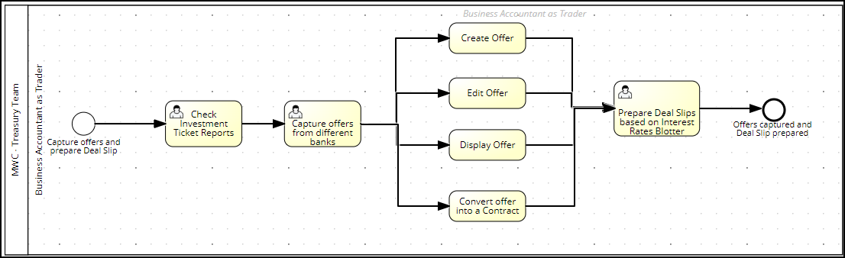

Layout
Not Applicable.

Assumptions in Functional Design
Not Applicable.

Open Issues in Functional Design
Not Applicable.

Business Test Conditions

Scenario # | Input Selection Criteria | Expected Result
1 | Create, edit and display offer for placements. | Offer created with applicable bids.  Details stored in the database table for subsequent reporting.  Edit or display the offer.
2 | Create, edit and display offer for forex. | Offer created with applicable bids.  Details stored in the database table for subsequent reporting.  Edit or display the offer.

Related Documentation
Not Applicable.

Deal Slips: -

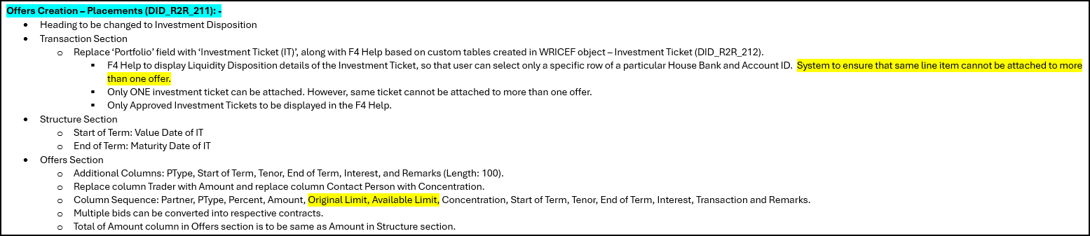
Offers Creation – Placements (DID_R2R_211): -
- Heading to be changed to Investment Disposition
- Transaction Section
  - Replace ‘Portfolio’ field with ‘Investment Ticket (IT)’, along with F4 Help based on custom tables created in WRICEF object – Investment Ticket (DID_R2R_212).
    - F4 Help to display Liquidity Disposition details of the Investment Ticket, so that user can select only a specific row of a particular House Bank and Account ID. (Company Code, Fiscal Year, Tkt No, House Bank, Acct ID, Amount, Maturity Date)
    - Only Approved Investment Tickets to be displayed in the F4 Help of Portfolio
    - Only ONE investment ticket can be attached. However, same ticket cannot be attached to more than one offer.
- Structure Section
  - Start of Term: Value Date of IT (based on CoCd, Fiscal year and Investment ticket no.)
  - End of Term: Maturity Date of IT (based on CoCd, Fiscal year and Investment ticket no. + Liquidity Disposition line item)
  - Amount: Amount from specific line item of Liquidity Disposition section of Investment Ticket (based on CoCd, Fiscal year and Investment ticket no. + Liquidity Disposition line item)
- Offers Section
  - Additional Columns: PType, TType, Start of Term, Tenor, End of Term, Interest, and Remarks (Length: 100).
  - Replace column Trader with Amount and replace column Contact Person with Concentration.
  - Column Sequence: Partner, PType, Percent, Amount, Original Limit (Internal Limit), Available Limit (Internal Limit – Utilization Amount), Concentration, Start of Term, Tenor, End of Term, Interest, Transaction and Remarks.
    - Logic of Interest:
  - Multiple bids can be converted into respective contracts.
  - Validation: Total of Amount column in Offers section is to be same as Amount in Structure section.

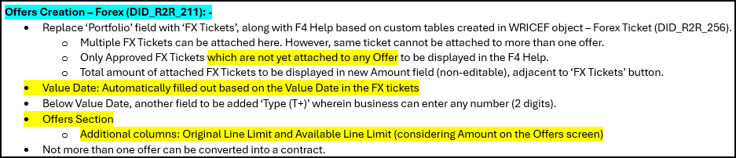
Offers Creation – Forex (DID_R2R_211): -
- Replace ‘Portfolio’ field with ‘FX Tickets’, along with F4 Help based on custom tables created in WRICEF object – Forex Ticket (DID_R2R_256).
  - Multiple FX Tickets can be attached here. However, same ticket cannot be attached to more than one offer.
  - Only Approved FX Tickets which are not yet attached to any Offer to be displayed in the F4 Help. For the company code & fiscal year,
    - ZTRM_FX_TKT_HDR: Company Code, Forex Tkt, Value Date,
    - ZTRM_FX_TKT_PUR: RFP No., Vendor, Amount
  - Total amount of attached FX Tickets to be displayed in new Amount field (non-editable), adjacent to ‘FX Tickets’ button.
- Value Date: Automatically filled out based on the Value Date in the FX tickets
- Below Value Date, another field to be added “Type (T+)” wherein business can enter any number (2 digits).
- Offers Section
  - Additional columns: Original Line Limit (Internal Limit) and Available Line Limit (considering Amount on the Offers screen)
    - Available Line Limit = Internal Limit – Utilization Amount – Amount on Offers Screen

